10th November 2015

TO: The Police and Crime Commissioner, Deputy Police and Crime Commissioner, Chief Constable, Deputy Chief Constable, Assistant Chief Constable, Director of Finance, Chief Finance Officer, Director of Resources and Director of Legal

Copy to: ACPO and Senior Officers/Staff
OPCC Staff
Press

Dear Sir/Madam,
A meeting of the Dyfed-Powys Policing Accountability Board will be held on Wednesday, 18th November 2015 at 10:00 p.m. in Pembrokeshire County Council Chambers, Haverfordwest for the transaction of the business on the attached agenda. Members of the Press and Public may attend this meeting. The meeting will also be web-cast, details of which can be found on the OPCC website.

Yours sincerely
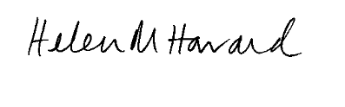

Dr H Morgan-Howard
Chief of Staff

Encl.

AGENDA - Priority 4: Enhancing Access to Policing Services

- Welcome and Apologies
- Minutes of the Accountability Meeting held on 15th October 2015 and Matters Arising
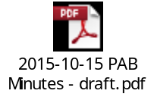
- Performance:
  - Force Accountability Report on Priority 4
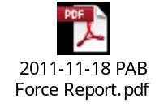
  - OPCC Accountability Report on Priority 4
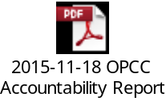
  - OPCC Monitoring Performance Report
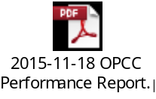
EXEMPT SESSION

- Domestic Abuse Problem Profile presentation (PAB 229, 250)
- Update Reports:
  - Questions from the Chief Officer Group minutes
- Action and Risk Summary from Meeting
- AOB

