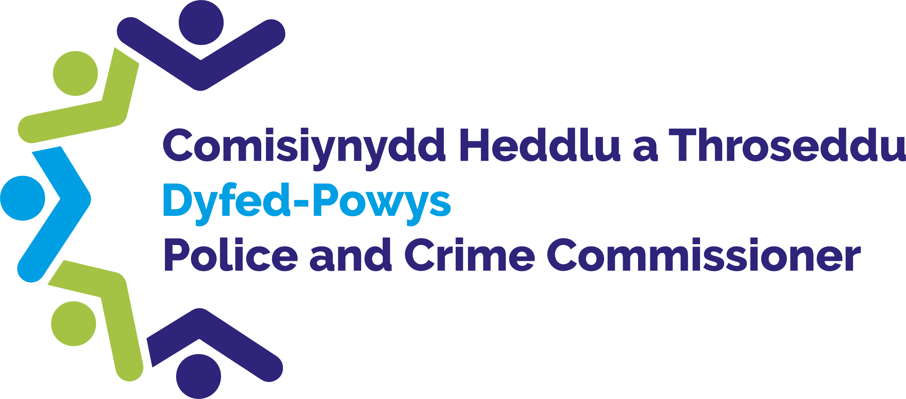

Police and Crime Commissioner for Dyfed-Powys

Scrutiny Panel
Dip Sampling Exercise

Hate Crime / women / disproportionality

Panel Members’ Findings & Feedback

October 2023

Contents

1.0 Overview 2
2.0 Background, purpose, and methodology 2
3.0 Approval by Panel Chair 2
4.0 Actions taken following previous panel meeting 3
5.0 Areas for improvement 3
6.0 Consideration of Hate Crime / women / disproportunality Adult cases 3
7.0 Consideration of Hate Crime / women / disproportunality Youth cases 6
8.0 Panel’s assessments to date 9
9.0 Ethnicity and Gender 14
10.0 Future Panel focus 15

Overview
On the 10th October 2023 Members attended the meeting of the Dyfed-Powys Out of Court Disposal Scrutiny Panel. Members reviewed a selection of youth and adult cases of Hate Crime / women and disproportionality, which had been dealt with by way of an Out of Court Disposal (OOCD). The Panel considered a total of 17 cases, 8 involving youth suspects and 9 involving adults.
This meeting was conducted virtually via Microsoft Teams.

Background, purpose, and methodology
Panel Members collectively agree an area of focus for each meeting. They receive relevant case files two weeks prior to each meeting which have been randomly selected by the Panel Chair. The Panel then meets to discuss each case and where possible reach a conclusion as to the appropriateness of the disposal. In deciding this, the Panel considers the following criteria:
• The views and feedback from the victim and the offender.
• Compliance with force policy.
• Rationale for the decision and outcome.
• Potential community impact.
• Circumstances and seriousness of the offence.
• Potential alternative options that may have been available.
The Panel discuss each case and categorise them as one of the following:
• Appropriate use consistent with policy.
• Appropriate use with Panel Members’ reservations.
• Inappropriate use or inconsistent with policy.
• Panel fails to reach a conclusion.

Approval by Panel Chair

I _David Evans__ _ (print name) can confirm that I have read the report, and that it fully represents the views expressed by the Panel during our dip sampling exercise dated 10th October 2023.

Signed: David Evans __
Date: 07.02.2024

Actions taken following previous panel meeting
As a result of the Out of Court Disposal Scrutiny Panel’s work, the following actions have been completed since the last meeting:
- An action was taken at the last meeting for Officers to be reminded of the correct process for issuing and Adult OOCD by following the Adult two tier gravity matrix. Chief Inspector (ChInsp) Jacqui Lovatt confirmed that this had been communicated across the Force to ensure compliance.
- An action was taken at the last meeting for the Adult gravity matrix to be re-sent to all OOCD panel members. This was completed on the 25th July 2023.
- An action was taken at the last meeting for a Senior Officer to be present at every OOCD panel meeting and if the designated officer is not available then a representative should attend. ChInsp Jacqui Lovatt informed that she will be replaced as the Senior Officer for the panel by Temporary ChInsp Matthew Price.

5.0 Areas for improvement
The following area for improvement was identified as a result of the Panel’s work this quarter:
- It was identified that some cases received were not complete. Panel members emphasised the need to receive complete case files. It was noted that this may have been caused by the implementation of NICHE within the Force.
- Panel members emphasised the importance of receiving all Bureau assessment reports and Bureau outcomes from all Youth Offending Teams across Dyfed-Powys.

6.0 Consideration of adult cases of Hate Crime/women and disproportionality
Nine adult cases of Hate Crime/women and disproportionality were considered.

Members’ assessment | Number of cases
Appropriate | 5
Appropriate with reservations | 1
Inappropriate | 2
Fail to reach a conclusion | 1

Panel Members’ observations are detailed below.
Case 1
The Panel acknowledged the nature of the case and noted that no further action was required. The Panel expressed their agreement with the use of the OOCD and noted that it was an appropriate use.
Panel’s Assessment: Appropriate
Case 2
The Panel acknowledged the offenders no previous convictions status and the nature of the incident. All Panel members were in agreement that this was an appropriate use of the OOCD.
Panel’s Assessment: Appropriate
Case 3
It was noted that the investigation was noted as ongoing and not all case files were available therefore the Panel noted it would be inappropriate to consider this case.
Panel’s Assessment: Failed to reach a conclusion
Case 4
The Panel agreed that the caution issued was appropriate for this case as the offender did not have any previous convictions and the seriousness of the incident was minimal.
Panel’s Assessment: Appropriate
Case 5
The Panel noted the positive action undertaken by the Police as the incident was managed sensitively and appropriately. The Panel noted the safety advice given to the injured parties (IP’s) and expressed the positiveness of this action being undertaken. The Panel noted the previous alcohol related convictions related to the offender and their status as the ‘town alcoholic’ and questioned whether a court hearing would be most suited due to the offenders history. Reservations were raised regarding the difficulties bringing the case to court. It was agreed that the OOCD was appropriate but the with reservations.
Panel’s Assessment: Appropriate with reservations
Case 6
The Panel noted that the IP’s wished to not pursue this incident further and questioned whether it was due to their profession as security workers and thus do not see themselves as victims. The Panel acknowledge the offenders no previous history and deemed the OOCD as appropriate.
Panel’s Assessment: Appropriate
Case 7
It was acknowledged by the Panel that this was a repeat offender who had previous offences against the IP. The Panel raised concerns that the offender had not learnt from the previous OOCD’s issued due to their history of repeat offending. The Panel agreed that this case demonstrated an inappropriate use of the OOCD.
Panel’s Assessment: Inappropriate
Case 8
The Panel noted the Offender’s failure to comply with the community order and the breach of the court order. The Panel noted their concerns for the offender due to the severity of the incidents. The Panel raised questions and noted that the files provided did not provide enough information. It was agreed that this was an inappropriate use of the OOCD.
Panel’s Assessment: Inappropriate
Case 9
The Panel members noted the concerns for the Offender’s wellbeing due to their age and their history of no previous convictions. The Panel questioned if the offender had any additional needs that may have lead them to committing this offence. The Panel acknowledged that the IP was not supportive of a prosecution and thus it was agreed that this was an appropriate use of the OOCD.
Panel’s Assessment: Appropriate

7.0 Consideration of Youth cases of Hate Crime/women and disproportionality
Panel members reviewed eight cases.
Members’ assessments were as follows:
Members’ assessment | Number of cases
Appropriate | 6
Fail to reach a conclusion | 2

Case 1
The Panel acknowledged the no previous history in connection to the offender. They questioned as to whether the individuals were referred to a Youth Offending Team (YOT) given that it was a street disposal that was issued. Overall the Panel were satisfied with the case and deemed it an appropriate use of the OOCD.
Panel’s Assessment: Appropriate
Case 2
It was agreed that the Panel could not reach a conclusion on case 2 as the case file was not complete. The Panel noted the importance of only receiving concluded and full case files as it would be inappropriate to review them otherwise.
Panel’s Assessment: Failed to reach a conclusion
Case 3
It was agreed that the Panel could not reach a conclusion on case 3 as the case file was not complete. The Panel noted the importance of only receiving concluded and full case files as it would be inappropriate to review them otherwise.
Panel’s Assessment: Failed to reach a conclusion
Case 4
The Panel noted the offenders possible lack of knowledge and understanding for the term used and noted the age appropriate advice given. It was acknowledged that a letter of apology had also been issued. The Panel determined that this was an appropriate use of the OOCD.
Panel’s Assessment: Appropriate
Case 5
Similar to case 4 the Panel questioned the offenders understanding of the term used and it’s seriousness. The gravity score matrix included within the case was acknowledged and it was determined that this was an appropriate use of the OOCD.
Panel’s Assessment: Appropriate
Case 6
The Panel questioned if the case was referred to the YOT and noted the absence of the bureau assessment from Powys YOT. A discussion ensued regarding the Force’s use of YOT and it was emphasised that Police Officers need to remember to contact their YOT contacts for any advice. The Panel agreed that this was an appropriate use of the OOCD as the offender had no previous convictions but further education was required which could be accessed via the OOCD.
Panel’s Assessment: Appropriate
Action 1: Police Officers to be reminded of their YOT contacts and the importance to contact them with any enquiries.

Case 7
The Panel complimented the detailed bureau assessment and plan provided by the Carmarthenshire YOT and noted it as an example of best practice. The Panel noted that the offender may have additional requirements and this was their first noted offence thus the OOCD was an appropriate use.
Panel’s Assessment: Appropriate
Case 8
The Panel noted this as a low level hate crime and no previous convictions by the offender. The Panel questioned the school’s involvement and questioned as to why a safeguarding plan was not issued. The Panel also raised concerns regarding the use of a Youth Caution. The Panel deemed this an appropriate use of the OOCD. A discussion ensued regarding the lack of YOT reports provided and the Panel emphasised on their importance. It was also suggested that a Powys YOT manager may wish to attend the next meeting. It was agreed that an invitation would be shared. The Panel also requested that the cases are equally provided from Powys and Dyfed for consistency.
Panel’s Assessment: Appropriate
Action 2: Reports to be provided by all relevant Youth Offending Teams.
Action 3: Powys YOT to be invited to the next Panel meeting.
Action 4: Equal number of Powys and Dyfed cases to be provided at the next Panel meeting

8.0 Panel’s assessments to date
The chart below demonstrates the Panel’s assessment Hate Crime/women and disproportionality cases considered at the most recent meeting:
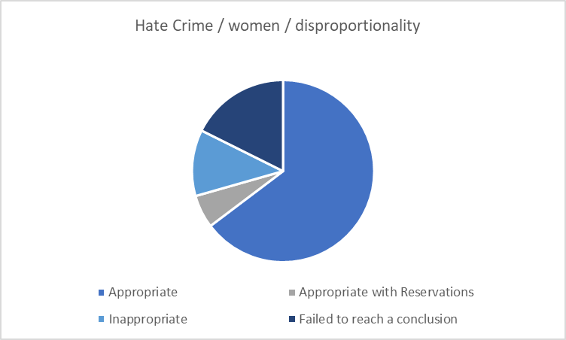
Since November 2013 the Panel has considered a range of disposals, as displayed in the graph below.
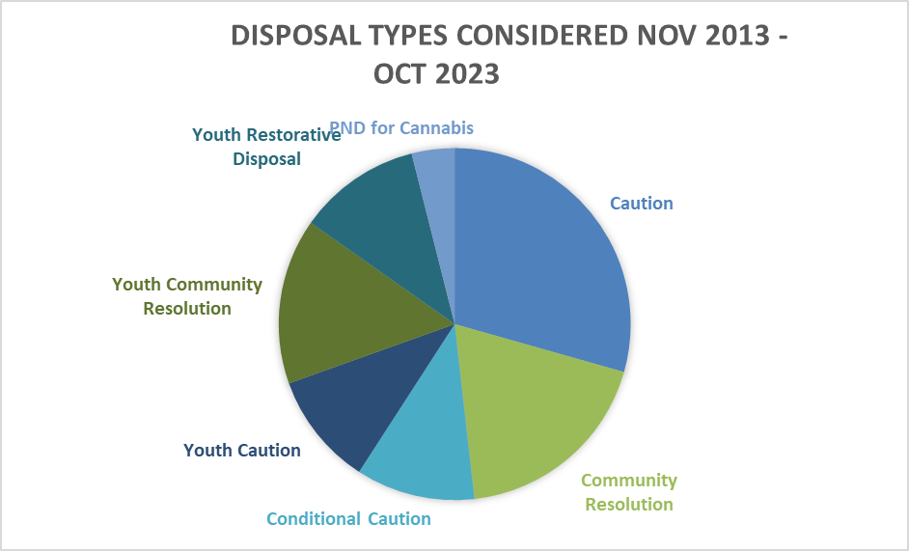

Of the 589 cases examined between November 2013 and October 2023, 58.5% were assessed as appropriate, 20% as inappropriate, 18.8% as appropriate with reservations and the panel failed to reach a conclusion in 2.5% of cases.
The change in conclusions reached over time can be seen in the graph below:

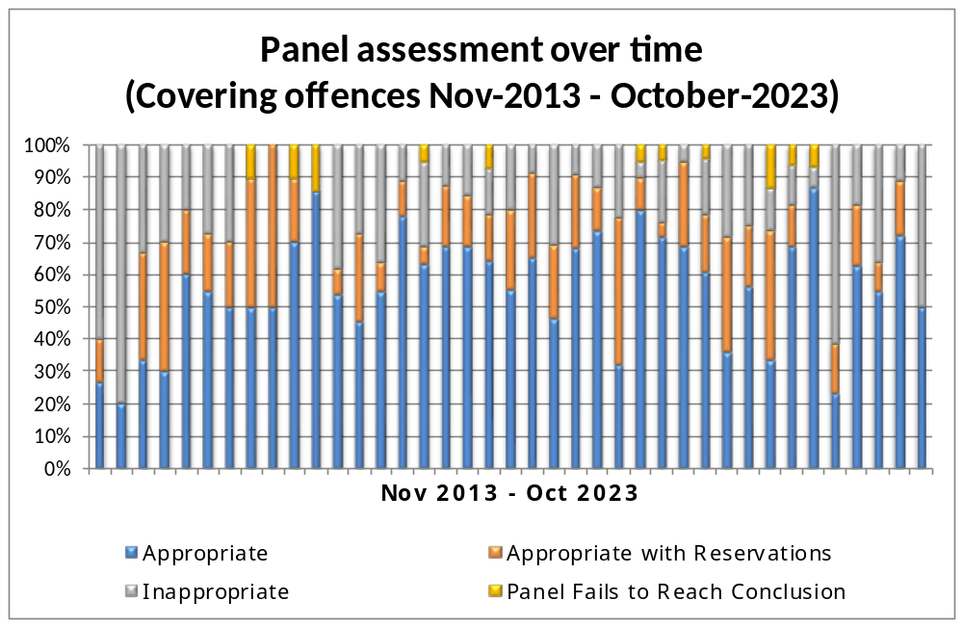

The graph below shows the breakdown by crime type as a percentage of cases considered between November 2013 and October 2023.

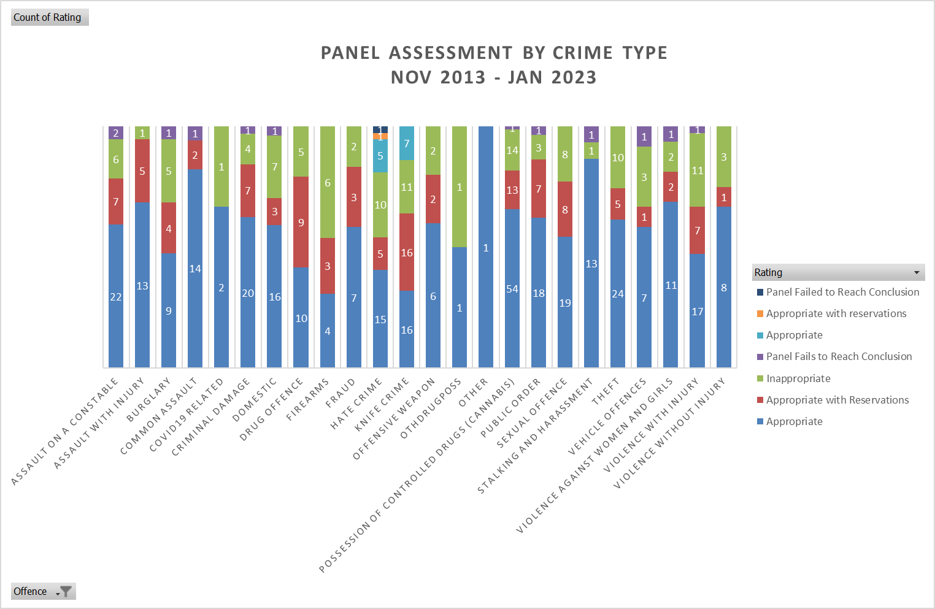

The following graph displays the actual number of cases assessed within each crime type and the resulting Panel opinions at their meetings between November 2013 and October 2023.

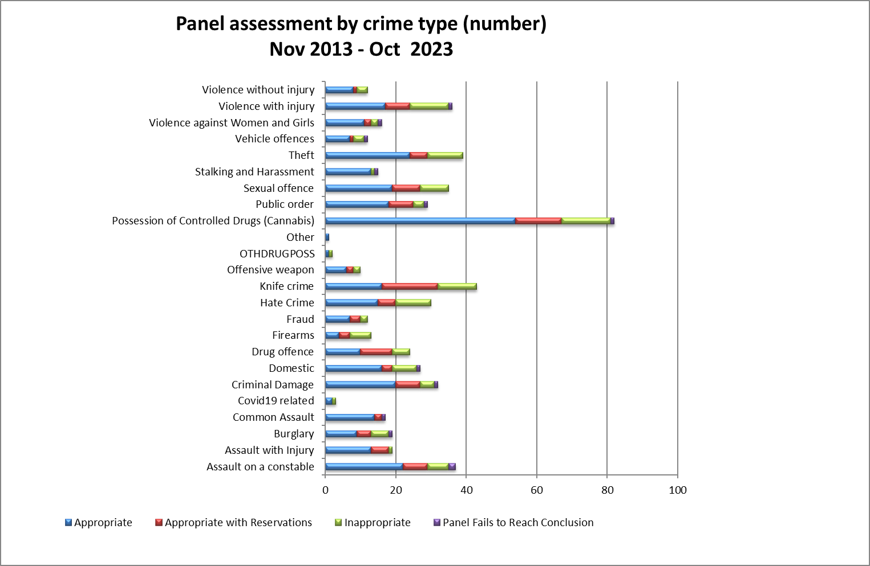

9.0 Ethnicity and Gender
The following chart shows the breakdown of cases reviewed within this meeting in terms of their gender:
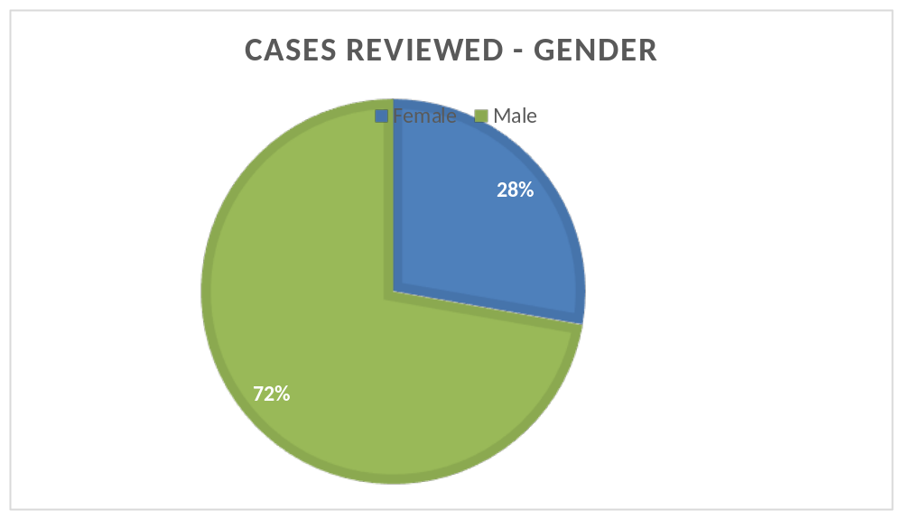

The following table shows the breakdown of cases reviewed within this meeting in terms of ethnicity.
Ethnicity Noted | Suspect’s  Self - Assessment | Officer’s Assessment
White British | 0 | 0
White – North European | 0 | 14
Mixed - White and Black Caribbean | 0 | 0
Unknown | 8 | 3
Black British | 0 | 0

There were no race or gender equality issues identified as part of the Panel’s review.

10.0 Future Panel focus
Following a discussion, it was decided by the Panel that they would like to focus on Rural Crime at the next meeting in February 2024.

