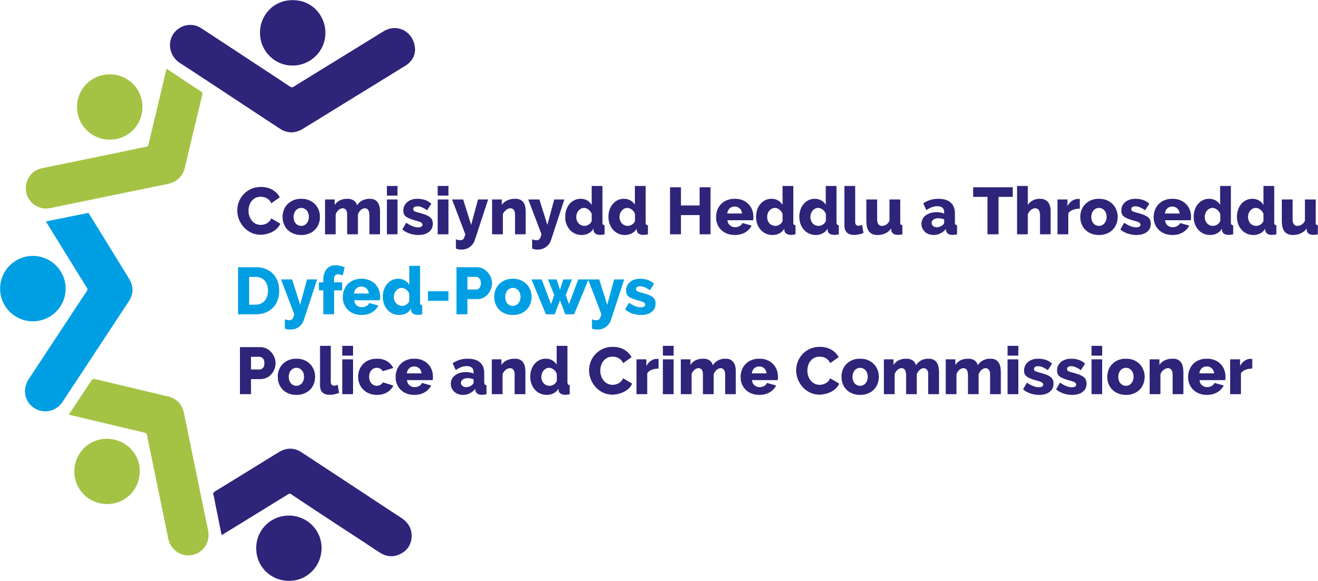

Police and Crime Commissioner for Dyfed-Powys

Scrutiny Panel
Dip Sampling Exercise

Review of Hate Crime and Firearms Cases

Panel Members’ Findings & Feedback

October 2022

Contents

1.0 Overview 2
2.0 Background, purpose and methodology 2
3.0 Approval by Panel Chair 2
4.0 Actions taken following previous panel meeting 3
5.0 Good practice 3
6.0 Areas for improvement 3
7.0 Consideration of assault on an emergency worker cases – youth suspects 4
7.1 Consideration of hate crime cases – youth suspects 6
8.0 Consideration of assault on emergency worker cases – adult suspects 8
8.1 Consideration of hate crime cases – adult suspects 9
9.0 Panel’s assessments to date 11
10.0 Ethnicity and Gender 14
11.0 Future Panel focus 16

Overview
On the 17th October 2022 Members attended the meeting of the Dyfed-Powys Out of Court Disposal Scrutiny Panel. Members reviewed a selection of hate crime and firearm cases, which had been dealt with by way of an Out of Court Disposal. The Panel considered a total of 13 cases, 8 involving youth suspects and 5 involving adults.
This meeting was conducted virtually via Microsoft Teams.

Background, purpose and methodology
Panel Members collectively agree an area of focus for each meeting. They receive relevant case files two weeks prior to each meeting which have been randomly selected by the Panel Chair. The Panel then meets to discuss each case and where possible reach a conclusion as to the appropriateness of the disposal. In deciding this, the Panel considers the following criteria:
• The views and feedback from the victim and the offender.
• Compliance with force policy.
• Rationale for the decision and outcome.
• Potential community impact.
• Circumstances and seriousness of the offence.
• Potential alternative options that may have been available.
The Panel discuss each case and categorise them as one of the following:
• Appropriate use consistent with policy.
• Appropriate use with Panel Members’ reservations.
• Inappropriate use or inconsistent with policy.
• Panel fails to reach a conclusion.

Approval by Panel Chair

I __David Evans_ (print name) can confirm that I have read the report, and that it fully represents the views expressed by the Panel during our dip sampling exercise dated 17th October 2022.

Signed: David Evans
Date: _ 30/01/2023 __

Actions taken following previous panel meeting
As a result of the Out of Court Disposal Scrutiny Panel’s work, the following actions have been completed since the last meeting:
- Crime Recording has included information on past Youth Restorative Disposals within the meeting case files.
- The Youth Restorative Disposal form was amended on the system to address the typing error.
- Feedback was passed back to Officers attending a performance event in relation to ensuring that crime logs are detailed, as files could be re-visited or reviewed by scrutiny panels.
- Feedback was given to Chief Inspectors to ensure that the Youth Offending Team and relevant agencies are involved in the decision making when issuing an Antisocial Behaviour Contract.

Good practice
The following good practice was identified as a result of the Panel’s work this quarter:
- A discussion took place in relation to the value of ensuring that a representative from CPS attends all OOCD meetings.

6.0 Areas for improvement
The following area for improvement was identified as a result of the Panel’s work this quarter:
- There is a need to ensure that all hate crime cases are referred to CPS for advice.

7.0 Consideration of firearms cases – youth suspects
Three firearms cases were considered, the cases were dealt with via: one Youth Caution and two Youth Restorative Disposals.
Members’ assessment | Number of cases
Appropriate with reservations | 1
Inappropriate | 2
Panel Members’ observations are detailed below.
Case 1
The suspect in this case had verbally threatened individuals with an imitation firearm and was given a Youth Restorative Disposal. Members felt that this case was inappropriately disposed due to the suspect having no learning, showing no remorse and no record of a full apology being noted. This was a serious incident due to the offence taking place outside a school.
Panel’s Assessment: Inappropriate

Case 2
The suspect in this case had been seen firing at a target outside of his bedroom window. Although this was the offenders first offence, Members felt that this case was inappropriately disposed via a Youth Restorative Disposal. It was noted that a Youth Restorative Disposal should not be given to a firearms offence. It was also noted the force did not liaise with the Youth Offending Team in relation to this case. It was felt that due to the seriousness of the offence, the investigation and report should have contained further detail in relation to the offence and firearm used.
Panel’s Assessment: Inappropriate

Case 3
The suspect in this case was given a Youth Caution for being found in possession of a number of weapons including a taser. Members had reservations in relation to this case due to its seriousness. Members also noted that the wrong gravity score was recorded, the score was noted as one, but should have been a three. It was also felt that the list of weapons found at the offender’s address was unclear.
Panel’s Assessment: Appropriate with reservations

8.0 Consideration of firearms cases– adult suspects
Panel Members reviewed two firearm adult cases. Both cases had been dealt with by way of Conditional Caution.
Members’ assessments were as follows:
Members’ assessment | Number of cases
Appropriate | 1
Appropriate with Reservations | 1

Case 4
This case was in relation to a firearm being located in the suspects vehicle. This individual was given a Conditional Caution. Although the policy was followed, Members had reservations about this case due to its seriousness and the large amount of drugs which were found in addition to the firearm. Members were undecided as to whether this case could have gone to Court.
Panel’s Assessment: Appropriate with reservations

Case 5
The suspect in this case was found in possession of 2 shotguns without a certificate and was given a Conditional Caution. Members had no concerns in relation to this case as the offender had offered a full apology, the firearms were within the legal power limit and the individual had already applied for a certificate, which was in progress at the time of the offence.
Panel’s Assessment: Appropriate

9.0 Consideration of Hate Crime cases– youth suspects
Panel Members reviewed five cases. Three had been dealt with by way of a Caution, one via a Youth Restorative Disposal and one via Community Resolution.
Members’ assessments were as follows:
Members’ assessment | Number of cases
Inappropriate | 5

Panel Members’ observations on each case are detailed below:
Case 6
The suspect in this case was given a Caution for creating a video of a racist nature. Although the suspect had stated that they were drunk, was remorseful and had written a letter of apology, it was found that a second video had been created following the first incident. Members felt that the case should have been re-visited and escalated. It was also noted that the case should have gone to CPS for advice as it was a hate crime incident. Positively members noted that the Youth Offending Team process was correctly applied.
Panel’s Assessment: Inappropriate
Action 1:
All Hate Crime cases should be referred to CPS for advice. Refresher training on the charging processes and the criteria for OOCDs is needed.
Action 2:
A reminder to be circulated to both officers and the Youth Offending Team that all hate crime cases should be referred to CPS for advice.

Case 7
This suspect was given a Caution for filming a racist video with threats to kill. Similarly to case 6, members felt that this case was serious and should have been referred to CPS for advice.
Panel’s Assessment: Inappropriate

Case 8
The suspect in this case had been given a Youth Community Resolution for calling the victim names of a homophobic nature. Members were unsatisfied with this outcome due to the individual showing no remorse and not admitting to the offence. Suspect did not accept his own words, an out of court disposal is not eligible without full admittance. It was also found that this case did not go to CPS as a hate crime for advice.
Panel’s Assessment: Inappropriate

Case 9
The suspect in this case had assaulted the victim making a racist comment. It was felt that this case had been inappropriately disposed via a Youth Caution as although the policy had been followed, the case had not gone to CPS for advice as a Hate Crime. It was also noted that the offence occurred in January, but the outcome was not finalised until July, this is a long time for a youth case.
Panel’s Assessment: Inappropriate

Case 10
The suspect in this case had made a racist remark against the victim and was given a Youth Restorative Disposal. Members felt that this outcome was inappropriate due to hate crime cases not being able to receive a Youth Retsorative Disposal. It was also noted that the case had not been referred to CPS for hate crime advice.
Panel’s Assessment: Appropriate

10.0 Consideration of Hate Crime cases– adult suspects
Panel Members reviewed three cases. One had been dealt with by way of a Caution and two via a Community Resolution.
Members’ assessments were as follows:
Members’ assessment | Number of cases
Appropriate | 2
Inappropriate | 1

Case 11
The victim in this case had received texts from the suspect which caused them distress. The suspect was given a Community Resolution. The Panel Members felt that this outcome was appropriate due to there being no evidence of the texts being of a homophobic nature.
Panel’s Assessment: Appropriate
Case 12
The suspect in this case was given a Community Resolution for being verbally and racially abusive towards staff in a shop. Although this case had not been referred to the CPS for advice, the Panel felt that this case had been appropriately disposed as no victims wanted to provide a statement.
Panel’s Assessment: Appropriate

Case 15
This case relates to the suspect receiving a Caution for using racist language towards security staff and a Police Officer. It was felt that this case was inappropriately disposed as it had not been referred to CPS for advice. It was also noted that although the case had recorded evidential difficulties in proving hate intent, there was a statement from an officer noting that they personally felt the language used was racist.
Panel’s Assessment: Inappropriate

9.0 Panel’s assessments to date

The chart below demonstrates the Panel’s assessment of firearm cases considered at the most recent meeting:
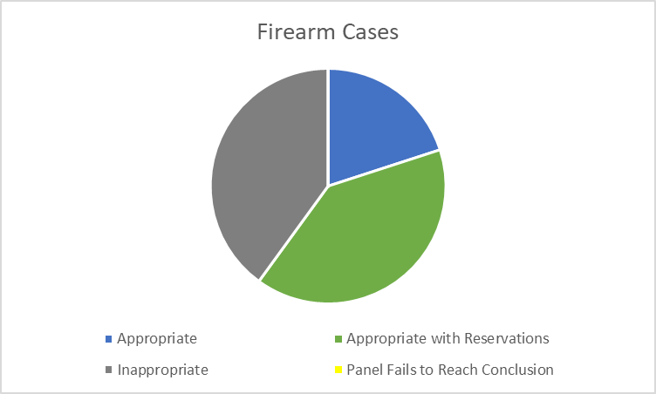
The chart below demonstrates the Panel’s assessment of hate crime cases considered at the most recent meeting:
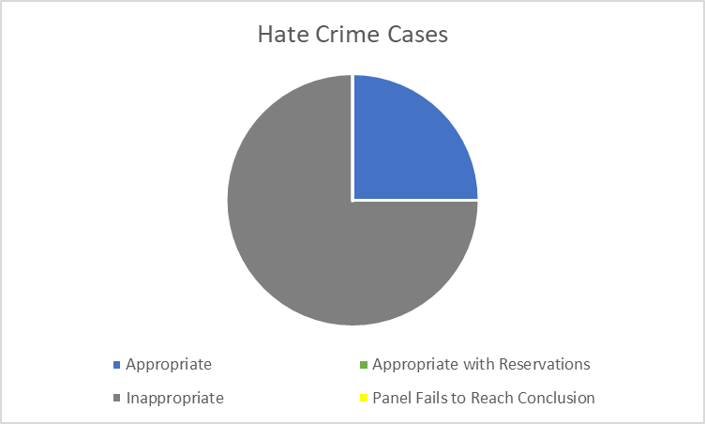
Since November 2013 the Panel has considered a range of disposals, as displayed in the graph below.
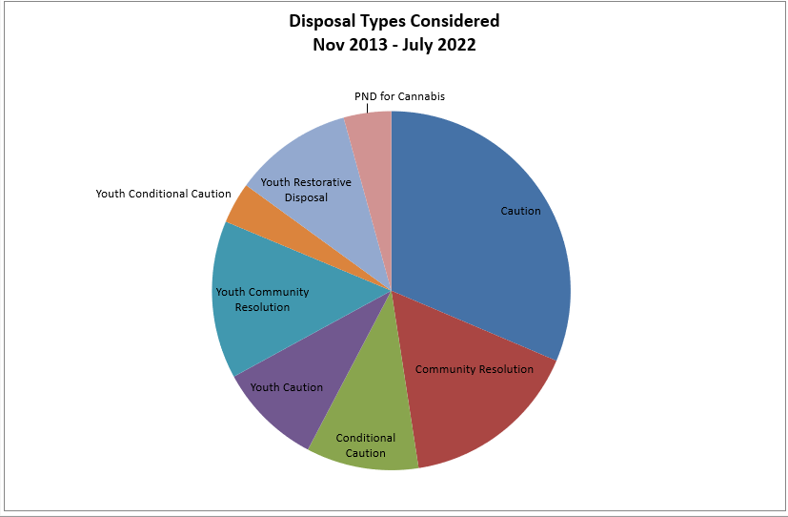
Of the 513 cases examined between April 2013 and October 2022, 57% were assessed as appropriate, 21% as inappropriate, 20% as appropriate with reservations and the panel failed to reach a conclusion in 2% of cases.
The change in conclusions reached over time can be seen in the graph below:
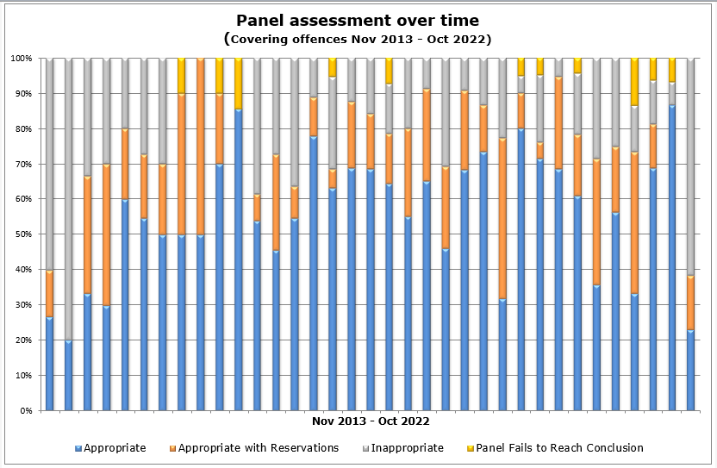
The graph below shows the breakdown by crime type as a percentage of cases considered between November 2013 and August 2022.
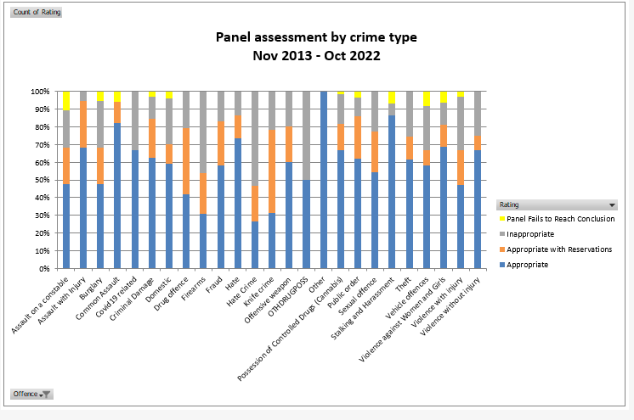
The following graph displays the actual number of cases assessed within each crime type and the resulting Panel opinions at their meetings between November 2013 and October 2022
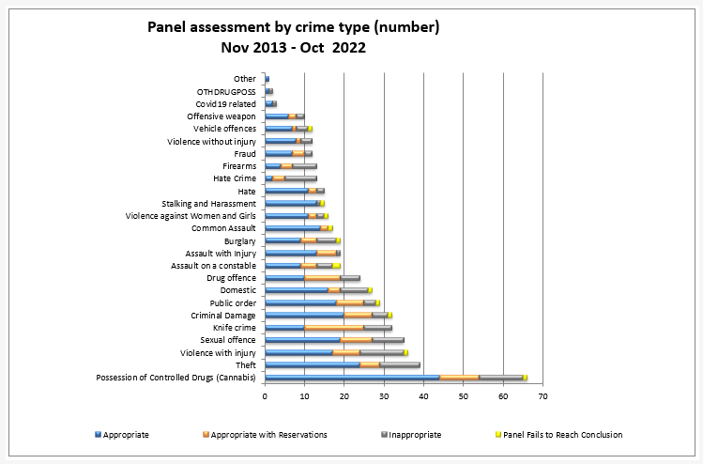

10.0 Ethnicity and Gender
The following chart shows the breakdown of cases reviewed within this meeting in terms of their gender:
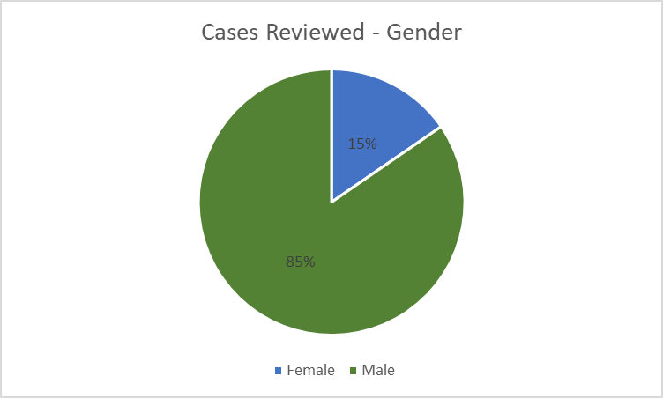

The following table shows the breakdown of cases reviewed within this meeting in terms of ethnicity.
Ethnicity Noted | Suspect’s  Self - Assessment | Officer’s Assessment
White British | 10 | 0
White - South European | 0 | 1
White - North European | 0 | 11
Unknown | 3 | 1

It was identified that where ethnicity had been recorded, all suspects identified as White - British but officers identified them as mostly White - North European.
There were no race or gender equality issues identified as part of the Panel’s review.

11.0 Future Panel focus
Following a discussion, it was decided by the Panel that they would like to focus on possession of drugs cases within the next meeting.
Action 3:
For the PCC to be invited to a future meeting and for consideration to be given to holding an in person meeting along with virtual meetings within the year.
Action 4:
Cases will be reviewed in future to try and remove any duplicate or unnecessary documents.

