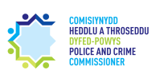
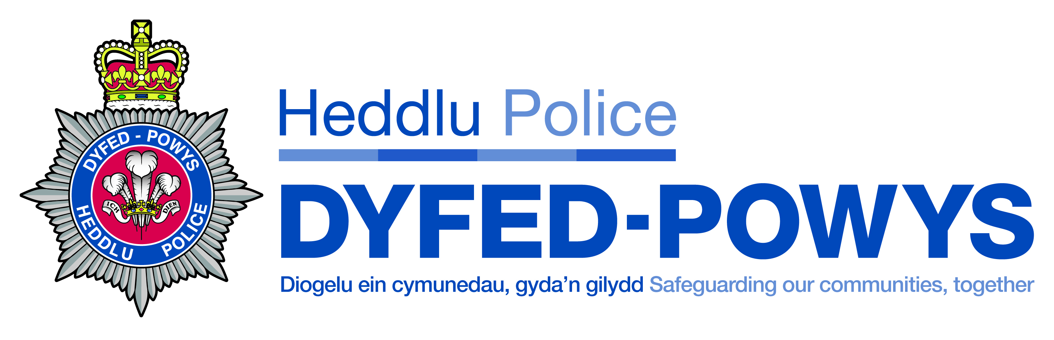
DYFED-POWYS
POLICE AND CRIME COMMISSIONER
AND
CHIEF CONSTABLE

Joint Audit Committee
Annual Report
2020/21

SAFEGUARDING OUR COMMUNITIES TOGETHER

Chairman’s foreword 2
Role of the Joint Committee and Membership 3
Meetings 4
Programme of work for 2020/21 5
Priorities for 2021/22 6

The Police and Crime Commissioner and Chief Constable’s Joint Audit Committee is independent of both the Chief Constable and Police and Crime Commissioner. This has been a very difficult year as a consequence of the restrictions resulting from the Covid-19 pandemic. It has meant that it has not been possible to hold face to face meetings although through the dedicated work of those responsible for the information technology systems it has been possible to hold meeting virtually. Under these difficult circumstances the members of the Committee have been able, in line with the Committee’s Terms of Reference, to provide advice and support to the Police and Crime Commissioner and the Chief Constable. It is with thanks to Audit Wales, as external auditors, and to TIAA, as the internal auditors, that they have undertaken their respective responsibilities so effectively under the difficult pandemic restrictions. This applies as well to those who provide support in servicing the committee. Although the Financial Statements were issued later than in previous years they were completed within the agreed revised timetable and that was a remarkable achievement by all concerned.

In line with the Terms of Reference Alasdair Kenwright, after completing two terms as a member of the Committee, attended his final meeting in December 2020. Besides being a previous Chair of the Joint Audit Committee, Alasdair had serviced as a member and a Chair of the Dyfed Powys Police Authority. His considerable experience of policing matters will be missed and I personally have benefitted greatly from his support. Having completed his first term as a member of the Committee Andre Morgan was re-appointed for a second term of four years enabling the committee to continue to benefit from his expertise. In March 2021 Lynne Hamilton joined the Committee and brings considerable public sector financial management knowledge to the work of the Committee. The effectiveness of the Committee is assisted by the considerable skills that the two other members, Martin Evans and Kate Curran, bring to the Committee. The support of all the Committee is greatly appreciated.

It is appropriate to record that the Committee has been supported by Chief Constable Mark Collins during his term of office and on his retirement In March 2021 the Committee wished him well for the future. Both he and the Police Commissioner have supported the Committee by their attendance unless unavoidable commitments prevent them from being present. Following the forthcoming Police Commissioner election and with the appointment of a new Chief Constable the Committee would wish to continue to provide a similar support role to the two office holders in undertaking their Corporation Sole responsibilities.

Besides the quarterly meetings of the Committee two seminars were held online. In June 2020 there was the opportunity to consider the annual accounts in greater detail. The work in preparing the Financial Statements does not always receive the appropriate recognition. Having the seminar provides the opportunity to examine the accounts in greater detail and is beneficial to those responsible for preparing the documents as well as the Committee. The second seminar was held in December 2020 and provides the opportunity to be advised of the financial pressures that would impact on the determination of the precept for 2021/22.

Each year an All Day Training event is held with the members of the other Welsh Joint Audit Committees. Exceptionally this year, two such events have been held; one on 22 June 2020 and the second on 23 March 2021. Both of these webinars were organised by CIPFA with additional presentations from Audit Wales. Although it was not possible to hold these events as previously face to face these events are invaluable in keeping the Committee updated with relevant current information and in having contact with the members of the other JACs in Wales.

The range of business undertaken is extensive and it important to note that the Committee members ensure that there is a detailed scrutiny of the various papers received. This included regular information on risk and this has highlighted how effectively Risk Management had become embedded in the governance arrangements of the Police and Crime Commissioner and Chief Constable. It is encouraging to record that there has been support from members of the Committee through being independent members of a range of committees for both the Police Commissioner and the Chief Constable.

Finally, on behalf of the Committee, I would like to thank officers of the Police and Crime Commissioner and the Chief Constable, along with the Internal Auditors, the staff of the Audit
Wales and representatives of Her Majesty’s Inspectorate of Constabulary, Fire and Rescue Services (HMICFRS) who have supported its work during the course of the year.
Malcolm MacDonald
Chair of the Joint Audit Committee
The JAC has been established in accordance with the Home Office Financial Management Code of Practice, issued under the Police Reform and Social Responsibility Act 2011 and in line with the Chartered Institute of Public Finance and Accountancy (CIPFA) guidance.
The Terms of Reference for the JAC summarise the core functions of the committee and the protocols in place to enable it to operate independently, robustly and effectively.

The Police and Crime Commissioner and Chief Constable’s Joint Audit Committee (JAC) is a key component of the Dyfed-Powys Police Service’s corporate governance. It provides an independent and high-level focus on the adequacy of audit, assurance and reporting arrangements that underpin good governance and financial standards. This independence is important as the committee is, therefore, uniquely positioned in terms of its ability to provide assurance and advice.
The purpose of the JAC is to provide independent assurance to the Police and Crime Commissioner (PCC) and Chief Constable (CC) on the adequacy of the governance and risk management frameworks, the internal control environment, and financial reporting, thereby helping to ensure efficient and effective arrangements are in place.

Members of the JAC must have an understanding of the financial, risk and control, and corporate governance issues facing the PCC and CC. They must have the ability to challenge, question, probe, and seek clarification from the PCC and CC when required.
The Membership of the JAC during 2020/21 was as follows:
Member | Number of meetings scheduled to attend | Number of meetings attended | % of meetings attended
Malcolm MacDonald (Chair) | 4 | 4 | 100%
Alasdair Kenwright | 3 | 3 | 100%
Martin Evans | 4 | 4 | 100%
Andre Morgan | 4 | 3 | 75%
Kate Curran | 4 | 3 | 75%
Lynne Hamilton | 1 | 1 | 100%

2020/21 saw some changes to the membership of the JAC. Mr Alasdair Kenwright’s term of office came to an end in December 2020 after 21 years of contribution to policing in the Dyfed Powys area. Alasdair joined the Police Authority as an Independent Member in 1999. Alasdair went on to be Vice-Chair and then Chair of the Authority. His role on the Joint Audit Committee began in 2013 and Alasdair has been a key member of the Committee for 8 years. Alasdair’s contribution to the work of both the Policing Authority, Dyfed-Powys Police and the PCC’s office has been extensive and very much appreciated by all.

A new JAC member, Ms Lynne Hamilton was appointed to the Panel in January 2021 and Mr Andre Morgan was re-appointed for a second term in January 2021. We look forward to working with you both over the next term.

Each member of the JAC have been vetted and completed a declaration of interest form.

Members were invited to the Police and Crime Commissioner’s virtual Finance Summit on the 9th of December 2020 which provided stakeholders with an overview of the operational and financial challenges facing the service. This served to contextualise the programme of governance work being undertaken by the JAC and was deemed to be beneficial to all involved. Members also received an input from Arlingclose, Treasury Management Advisors on the current economic position, market conditions and explained the key elements which needed consideration for the Strategies.

To support Members’ development, an All Wales training day for Joint Audit Committee Members took place virtually on the 23rd March 2021. This session was facilitated by CIPFA and provided Members with an opportunity to learn about the latest strategic and finance issues in policing, the latest governance and audit isses and to receive an update on the Treasury Management Function, Audit Wales and CIPFA developments.

The JAC meetings are also attended by the PCC and CC, the PCC’s Chief Finance Officer and Chief of Staff & Monitoring Officer and the CC’s Director of Finance. Other officers attend to provide information about audits, programmes of work, or any other matters as required.
Throughout 2020-21, JAC meetings have taken place virtually via Skype for Business due to COVID-19. Meeting virtually has meant that the work of the Committee has been able to continue without pause throughout the period.
On the 30th of April 2020 the Committee were invited to an online session which aimed to provide JAC members with an update on the Organisations’ position in response to the current Covid-19 pandemic. The agenda included an update on the impact on the organisations, the governance arrangements in place, financial implications, risk management and the impact on the internal audit plan.
On the 22nd June 2020 JAC attended an All Wales training webinar with CIPFA which gave an update on Covid-19 and the financial challenges for the sector, as well as specific training relevant for Police Audit Committees. Feedback from Members highlighted the effectiveness of the virtual approach and ability to share learning with other committees in Wales.

In addition to the formal Committee meetings, Members of the JAC also meet privately, without the PCC or CC, with both internal and external auditors on a bi-annual basis. It is also routine for the Chairman to have discussions with the Statutory Officers about emerging governance related issues.

A seminar was held virtually via Skype for Business on the 16th June 2020 between Members, the Chief Finance Officer, the Director of Finance and finance leads within the Force to consider the vast level of detail within the then draft Statement of Accounts. This exercise was considered very useful in terms of reviewing the accounts and related documents with very valuable discussions taking place. The Committee also had an input on the Annual Governance Statement and an update from Audit Wales.

‘I am satisfied that the Commissioner and Chief Constable had appropriate arrangements in place in the year to secure economy, efficiency and effectiveness in their use of resources’ Audit Wales Annual Audit letter for 2019-20 received by the Committee in December 2020.

Governance: The JAC received the actions taken from the quarterly Corporate Governance Group meetings, which is attended by representatives of the Chief Constable and Commissioner, and a JAC member. This Group maintains and reviews the effectiveness of the Corporate Governance Framework and considers the internal and external factors which impact on corporate governance. JAC members approved the draft Annual Governance Statements for both the PCC and CC and inputted into the revision of the Corporate Governance Framework.
Following a review the Audit and Quality Assurance Group was renamed as the Audit Governance Group to reflect a change in its focus. Membership to this Group consists of a small core group of individuals in addition to TIAA and representation from a JAC member. The group consider the progress made against audits and consider any prior recommendations that are outstanding.
Financial reporting: The JAC reviewed the annual Statement of Accounts for 2020/21, and considered the Accounting Policies, Treasury Management Strategy, Reserves Policy and the Capital Strategy.
Internal controls: The contract with TIAA was due to come to an end in March 2021 with an option to extend the contract for an additional year. Due to the challenges this year in terms of Covid-19 and timescales, the Force has taken advantage of the one-year extension, securing TIAA until March 2022.
Internal Audit: The JAC had oversight of work undertaken by internal auditors (TIAA), including reviews of Counter Fraud, Vetting Of Contractors, HR Management, Payroll, Pensions, Fixed Assets, Risk Management Mitigating Controls and Estates Management – Governance. The JAC also considered the Annual Internal Audit Plan for 2021/22.

The Joint Audit Committee met 4 times in 2020/21. The Committee received reports, recommendations and observations from internal auditors TIAA, Audit Wales Office and HMICFRS updates. The Committee also received presentations from officers of the OPCC and Force on key business areas for them to formulate an independent opinion and provide an assurance to the PCC and CC in respect of the financial and governance controls within the Corporation Soles. The programme of work included the following:

Risk Management: The JAC note the ongoing work within the Force to create a culture of engagement and ownership across the spectrum of risk management activity. The JAC is pleased to note the Internal Auditors award of Substantial Assurance to risk management mitigating controls in August 2020, which consolidated the similar award achieved in 2019. The JAC particularly note the Auditor’s positive comments in relation to risk management arrangements being embedded and underpinning sound governance arrangements that support the Force in achieving strategic goals and objectives through informed decision making. The JAC has monitored progress throughout 2020 in relation to the Force’s response to the risks and uncertainties created by the Global Coronavirus Pandemic and recognise the achievements that have ensured the continuing delivery of policing services in the face of such challenges. The JAC note the continuing risks faced by the Force in relation to Force Communication Centre fall-back arrangements and the criminal justice related challenges brought by uncertainties within the Forensic Science Service capability to meet the needs of policing across the UK.

HMICFRS: The JAC received updates on HMICFRS inspection activity and the Force Management Statement over the course of the year.

Did you know….almost 25% of all calls for service to Dyfed-Powys Police relate to concerns for a person’s welfare and safety? Crime only accounts for approximately 12% of all Dyfed-Powys Police calls for service. 11% of call for police assistance relate to anti-social behaviour and 16% to road traffic incidents and disruption.

Did you know….in an average week in 2016 Dyfed-Powys Police recorded 437 crimes.

Priorities for the Committee in 2021/22 include:
- To continue to oversee the integration of risk management into business planning and governance arrangements arising from COVID-19.

- To consider and advise upon recovery plans following COVID-19, particularly the governance, finance and organisational policies.

- To assess the lessons to be learnt, including the effectiveness of the Business Continuity arrangements, that were required during COVID-19.

- To continue to monitor the opportunities for collaborative w0rking with other Forces to increase efficiencies, resilience and value for money.

- To assess the ability to operate in continuing periods of financial constraints and to consider the implications of the Public Spending Review and funding formula changes

- To focus on information management arrangements and Crime Data Integrity and to ensure compliance with statutory requirements

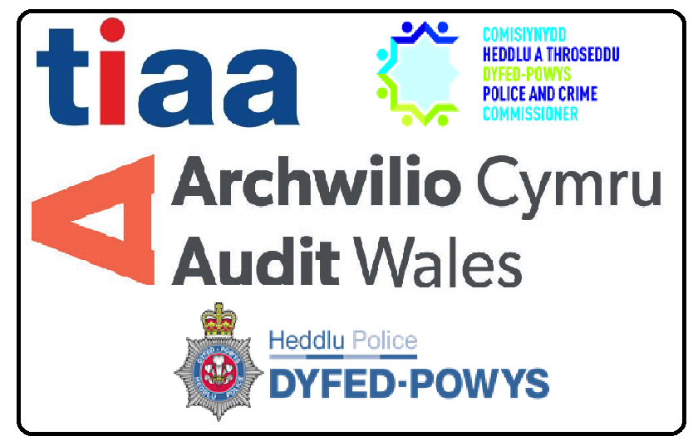

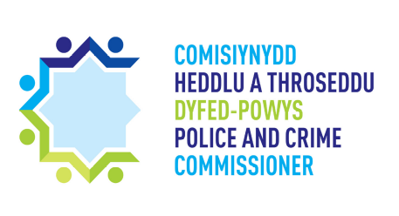

Contact the PCC
Tel: 01267 226440
Email: opcc@dyfed-powys.pnn.police.uk
OPCC, PO Box 99, Llangunnor, Carmarthen, SA31 2PF
Contact the Police
Tel: 01267 222020 / 101
PO Box 99, Llangunnor, Carmarthen, SA31 2PF



